NAME: Sandeep Kumar Rai

GITHUB_LINK: https://github.com/raisandeepkmr/assignment_5.git

VIDEO_LINK: <https://drive.google.com/drive/folders/1q9I_ieoHe8qptl8f4KPiyi8jqV8kGqF4?usp=sharing>

**In class programming:**

1. Principal Component Analysis

a. Apply PCA on CC dataset.

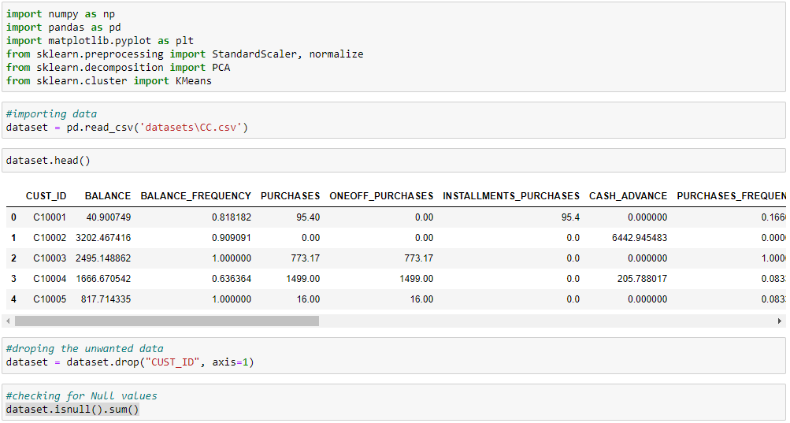

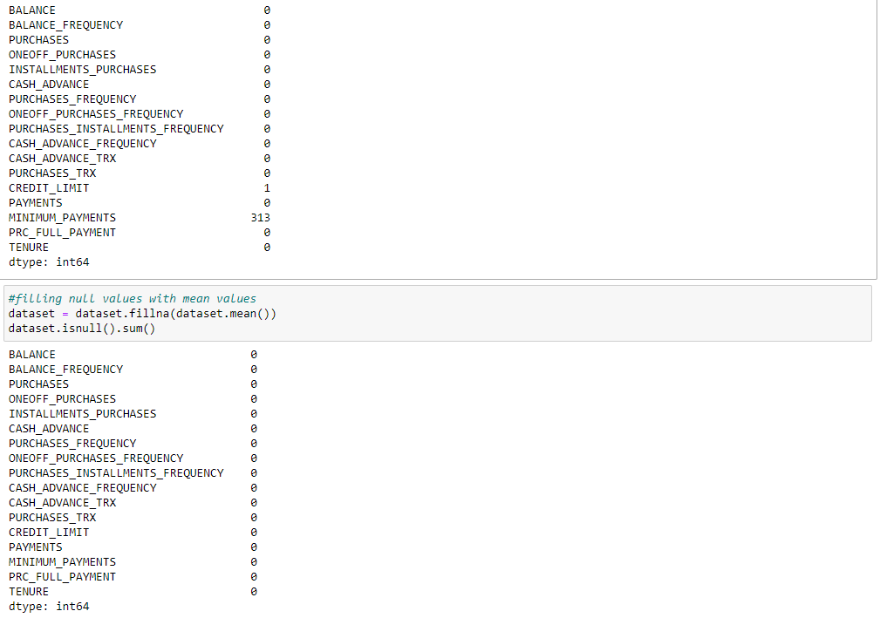

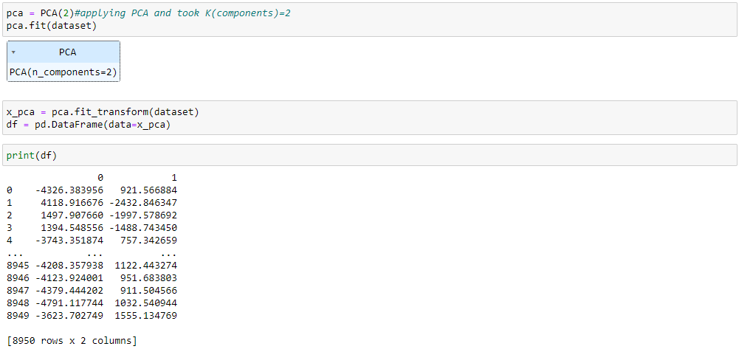

b. Apply k-means algorithm on the PCA result and report your observation if the silhouette score has improved or not?

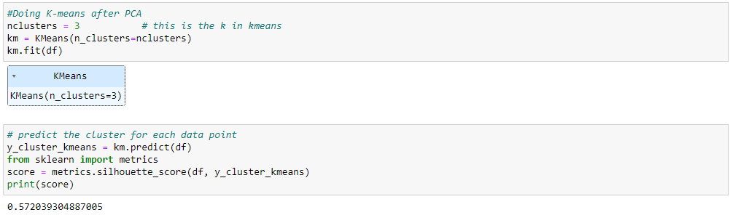

c. Perform Scaling+PCA+K-Means and report performance.

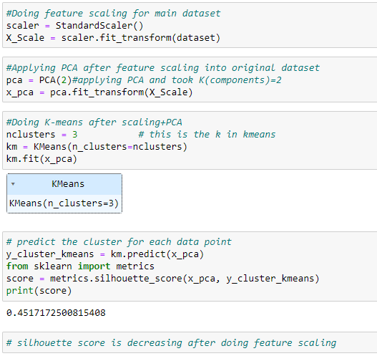

2. Use pd_speech_features.csv

a. Perform Scaling

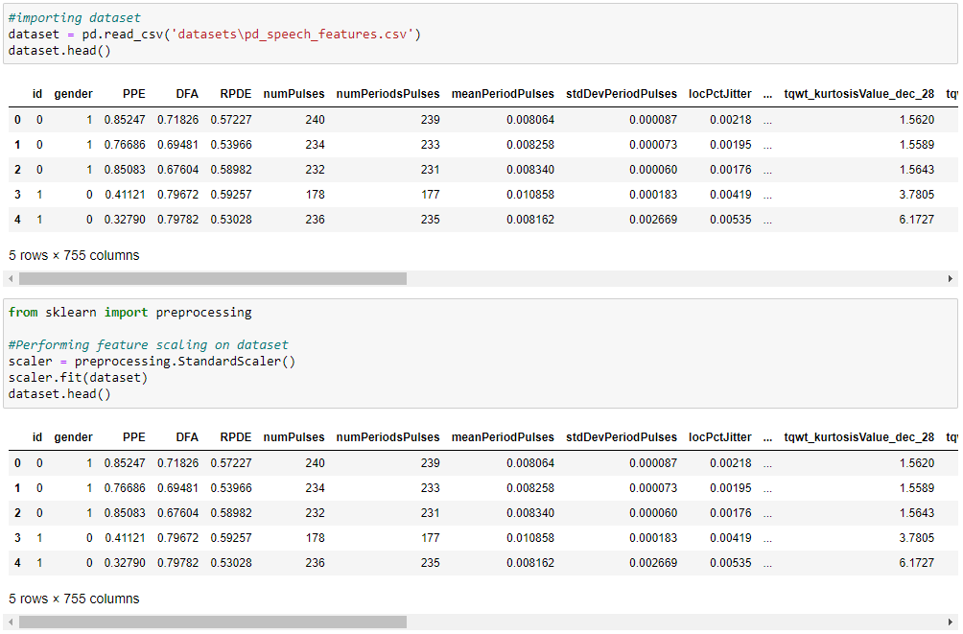

b. Apply PCA (k=3)

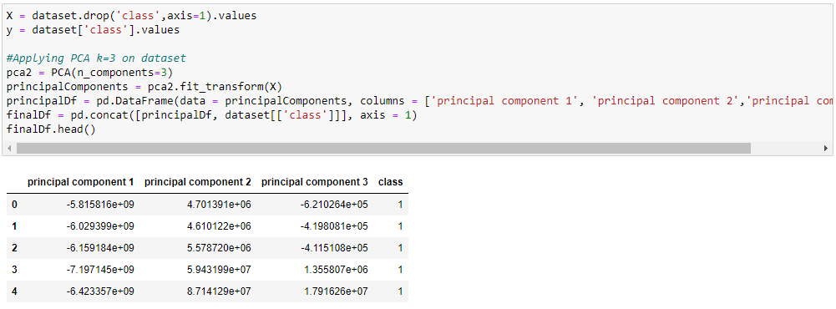

c. Use SVM to report performance

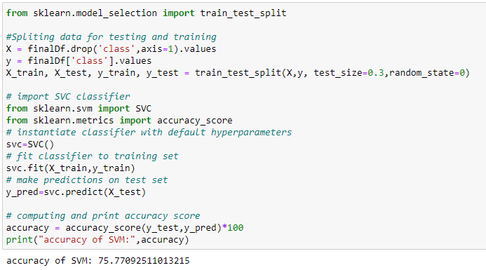

3. Apply Linear Discriminant Analysis (LDA) on Iris.csv dataset to reduce dimensionality of data to k=2.

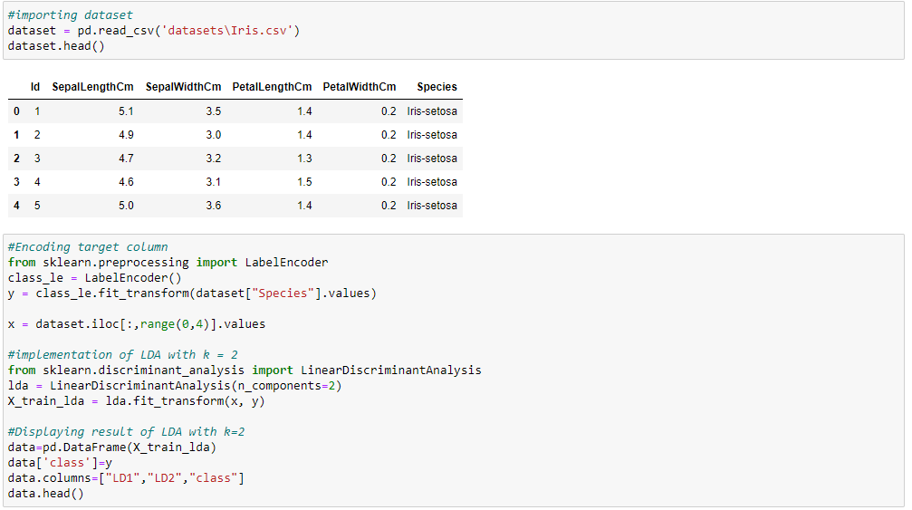

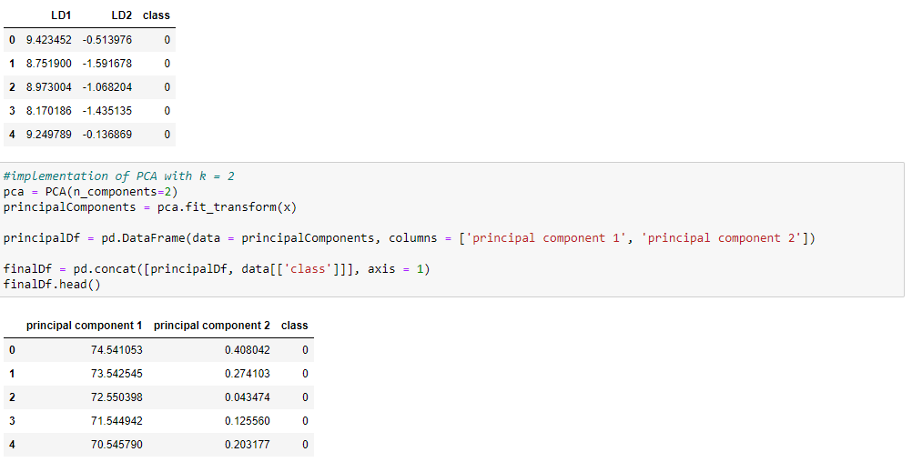

4. Briefly identify the difference between PCA and LDA

